Problem-1: Write a C++ program to create and display a singly linked list.(Traversing)
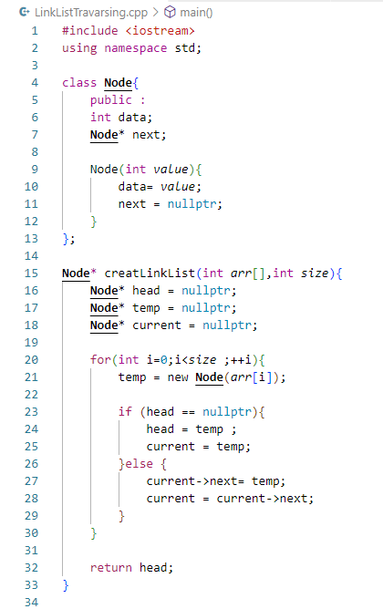
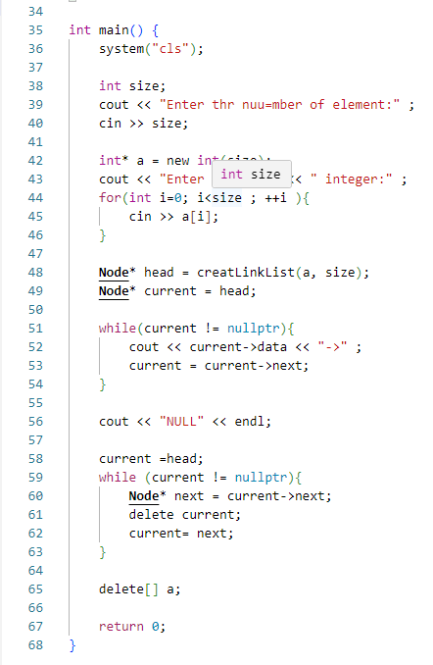
Code:

Output:
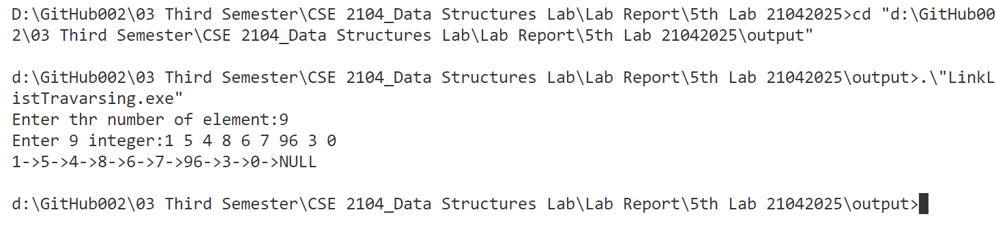

Problem-2: Write a C++ program to create and search an element in a singly linked list.
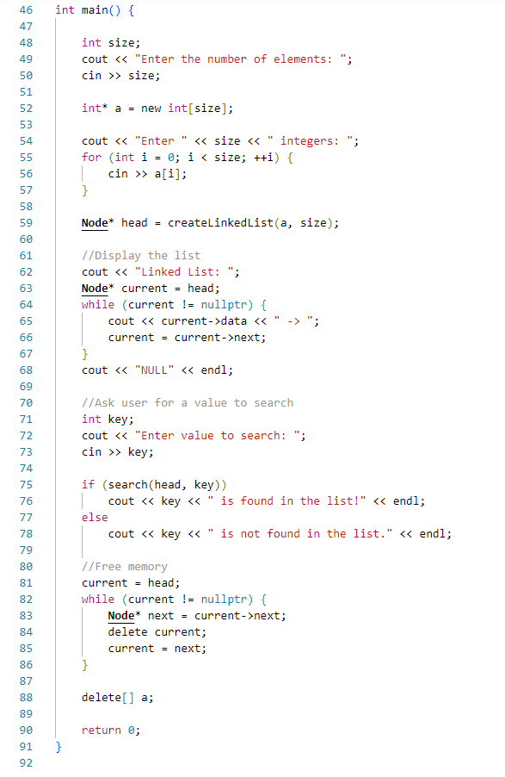
Code:
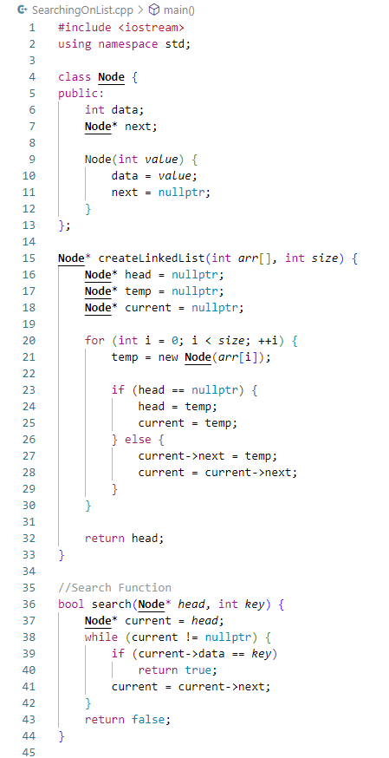

Output:
